Instructor |  | Due Date

Exercise | 1 | 2 | 3 | 4 | 5 | 6 | 7 | 8 | 9 | 10 | 11 | 12 | 13 | 14 | 15 | 16 | 17 | 18 | 19 | 20 | 21 | 22 | 23 | 24 | 25 | Total
Points | 4 | 4 | 4 | 4 | 4 | 4 | 4 | 4 | 4 | 4 | 4 | 4 | 4 | 4 | 4 | 4 | 4 | 4 | 4 | 4 | 4 | 4 | 4 | 4 | 4 | 100 points

Score

Textbook Reading Assignment

Thoroughly review your course lecture notes for the topic(s) given below.

Various Topics in Numerical Methods and Numerical Analysis

Use Mathematica / WolframAlpha to solve each of these.

Show all necessary work to answer each of the following.

(1) ( Interval Approximation )

Enter the following numerical expression, containing fractions, into WolframAlpha or Wolfram Mathematica.

(1 - 1/3 + 1/5) / (1/2 - 1/4 + 1/6)

Observe the result and then write an interval, in the form [ a , b ] where a and b are decimal numbers, for which the answer is to be contained. Ensure that your interval is within 10 % of the true answer. For example, if the exact result was 3.8 , you could write [ 3.61 , 3.99 ] as the interval.

(2) ( How Many Quintillion? )

Determine the place value of the digit 3 in the number. 249038401120719846712245

(3) ( The Runge - Kutta Method )

Use the Runge - Kutta Method to approximate a solution to an ordinary differential equation ( ODE ) .

Enter the following in Wolfram Mathematica.

Runge-Kutta method, dy/dx = -2xy, y(0) = 2, from 1 to 3, h = .25

Also, run the same command but change the step size to 0.10 and observe the new result. Now find the difference between the two results.

(4) ( Differential Equations )

When using WolframAlpha or Wolfram Mathematica, the following differential equation

y '' + y = 0 , y ( 0 ) = 2 , y ' ( 0 ) = 1

can be solved using this Mathematica command.

DSolve[{y[x] + y''[x] == 0, y[0] == 2, y'[0] == 1}, y[x], x]

Observe the resulting answer and then find the coefficients A , B of the general solution.

y ( x ) = A sin ( x ) + B cos ( x )

Note: when using WolframAlpha, use an input commnad such as this

y[x] + y''[x] == 0, y[0] == 2, y'[0] == 1

(5) ( The Doppler Shift )

The Doppler Shift measures the ratio between emitted and observed sound frequencies due to relative motion.

Execute this command to determine the observed frequency for these Doppler Shift values.

Doppler Shift 300Hz, 75mph

Also, what value for the speed of sound ( in feet per second ) was used in the resulting answer?

(6) ( Spring Pendulum )

Execute this command in WolframAlpha and determine the final length, in feet.

spring pendulum l0 = 0.12 ft, li = 0.24 ft, theta = 80 deg

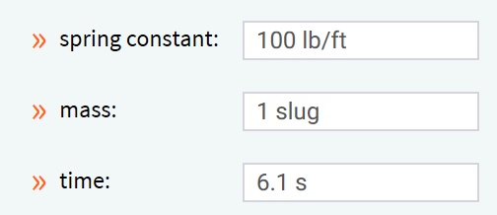

(7) ( Comparing Graphical Representations of Data )

Individually, enter these commands in WolframAlpha.

cost of 400 kWh of electricity in Illinois

cost of 400 kWh of electricity in Minnesota

Using the Windows Snipping Tool or similar screen capture program, take a screen of the results of these separate commands. Then, analyze and comment on the similarities or differences between the two graphs.

(8) ( Comparing Graphical Representations of Data )

Generate a Pythagoras Tree with these settings. Observe the form / structure of the tree and take a snapshot of it.

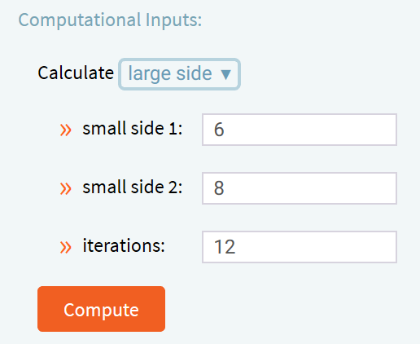

(9) ( Convert Between Number Bases )

In WolframAlpha, execute this command.

convert 2fec6 base 16 to base 10

Which of the two numbers, the original base 16 number or the resulting base 10 number, have the greatest number of digits, ignoring zero leading digits?

(10) ( Generate Sound with a Specified Waveform )

WolframAlpha has the ability to play sounds, especially when formed from mathematically produced graphs.

Execute the following WolframAlpha command and listen to the sound produced by the underlying wave.

play 1.2kHz sawtooth

Then, compare the sound produced by the following command.

play 1.5kHz sawtooth

Take screen snapshots of both waves. Which of the waves has the greatest frequency?

(11) ( Generate sound with a Specified Waveform )

Execute the following WolframAlpha command and listen to the sound produced by the underlying wave.

play sin(3000t) + sin(4243t)

Then, execute this modified command.

play sin(3000t) + sin(4t)

Comment on the differences in the tones and waveforms of the resulting waves.

(12) ( Gram - Schmidt Orthogonalization )

Run this command in WolframAlpha.

orthogonalize {1,2}, {3,-4}

Determine the characteristic polynomial formed by the orthogonalization process.

(13) ( Mersenne Prime )

Mersenne prime numbers have uses in cryptographic systems.

mersenne prime

Determine the twelfth sequence number of the set of Mersenne primes.

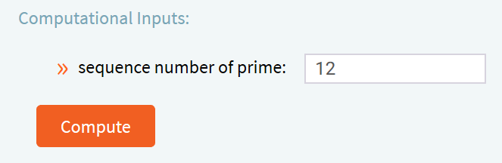

(14) ( Partial Fractions )

For the following WolframAlpha command, how many individual terms are returned?

partial fractions (x^2-4) / (x^4-x)

How many of the terms have denominators that are linear in order?

(15) ( Recursive Function )

For the following WolframAlpha command, what is the order ( linear, quadratic, cubic, etc. ) of the resulting recurrence equation solution?

g(0) = 1, g(n+1) = n^2 + 3 + g(n)

(16) ( Euler Phi Function )

Explain why this command returns the value that is observed in WolframAlpha.

Euler phi of 16

(17) ( Trapezoidal Rule )

Type this command in WolframAlpha and then approximate the integral of the given function for these parameters.

trapezoidal rule

function to integrate: y = cos ( x ) + x ²

interval size: 0.20

lower limit: 0

upper limit: 3

(18) ( Runge - Kutta Method Calculator )

Type this command in WolframAlpha and then approximate the solution of the given differential equation for these parameters. Use your own feasible / realistic additional parameters, if required.

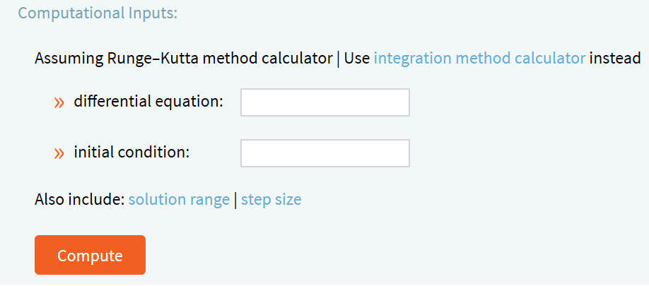

differential equation: y ' ( x ) = − 2 x y ( x )

initial condition: y ( 0 ) = 2

(19) ( Continuous Functions )

Run the following WolframAlpha command to determine if the underlying function is continuous. If there is a point of discontinuity, indicate this via a screen snapshot.

is sin(x - 1.1)/(x - 1.1) continuous

(20) ( Number Theory )

Commands such as the following will total the individual digits of a number.

add up the digits of 2567345

Run a similar command to add the digits of this number: 3729819189

(21) ( Fibonacci Numbers )

Run the following WolframAlpha command.

sequence of Fibonacci numbers

Then, determine whether 2,178,309 is a Fibonacci. Take a screen snapshot to prove or disprove your answer.

(22) ( Compute an Indexed Sum )

Execute the following WolframAlpha command but first replace the ? with a final value of index j which will yield a sum of 338,350 .

sum j^2, j = 1 to ?

Take a screen snapshot showing your correct index choice for j .

(23) ( Compute an Indexed Product )

Execute a command in WolframAlpha or Wolfram Mathematica that determines the product ∏ of the sequence of expressions ( k + 2 ) / k from k = 1 to k = 25 .

Use a command of the form:

product sequence_expression, range_of_index

(24) ( Compute an Indefinite Integral )

Execute the following command in WolframAlpha or Wolfram Mathematica.

integrate x^2 sin^3(x) dx

View the results and then capture an image of the plot of the integral in the domain of
− 25.1 ≤ x ≤ + 25.1 .

(25) ( Find a Taylor Series Expansion )

Execute the following command in WolframAlpha or Wolfram Mathematica.

taylor series sin x

View the result and then take a screen snapshot of the term in the series that has a denominator equal to 355,687,428,096,000 .

